Spring AOP Tutorial

1. [What is AOP?](http://www.javatpoint.com/spring-aop-tutorial)
2. [Where use AOP?](http://www.javatpoint.com/spring-aop-tutorial)
3. [AOP Concepts and Terminology](http://www.javatpoint.com/spring-aop-tutorial)
4. [Spring AOP Implementation](http://www.javatpoint.com/spring-aop-tutorial)

**Aspect Oriented Programming** (AOP) compliments OOPs in the sense that it also provides modularity. But the key unit of modularity is aspect than class.

AOP breaks the program logic into distinct parts (called concerns). It is used to increase modularity by **cross-cutting concerns**.

A **cross-cutting concern** is a concern that can affect the whole application and should be centralized in one location in code as possible, such as transaction management, authentication, logging, security etc.

**Why use AOP?**

It provides the pluggable way to dynamically add the additional concern before, after or around the actual logic. Suppose there are 10 methods in a class as given below:

1. **class** A{
2. **public** **void** m1(){...}
3. **public** **void** m2(){...}
4. **public** **void** m3(){...}
5. **public** **void** m4(){...}
6. **public** **void** m5(){...}
7. **public** **void** n1(){...}
8. **public** **void** n2(){...}
9. **public** **void** p1(){...}
10. **public** **void** p2(){...}
11. **public** **void** p3(){...}
12. }

There are 5 methods that starts from m, 2 methods that starts from n and 3 methods that starts from p.

**Understanding Scenario** I have to maintain log and send notification after calling methods that starts from m.

**Problem without AOP** We can call methods (that maintains log and sends notification) from the methods starting with m. In such scenario, we need to write the code in all the 5 methods.

But, if client says in future, I don't have to send notification, you need to change all the methods. It leads to the maintenance problem.

**Solution with AOP** We don't have to call methods from the method. Now we can define the additional concern like maintaining log, sending notification etc. in the method of a class. Its entry is given in the xml file.

In future, if client says to remove the notifier functionality, we need to change only in the xml file. So, maintenance is easy in AOP.

**Where use AOP?**

AOP is mostly used in following cases:

* to provide declarative enterprise services such as declarative transaction management.
* It allows users to implement custom aspects.

AOP Concepts and Terminology

AOP concepts and terminologies are as follows:

* Join point
* Advice
* Pointcut
* Introduction
* Target Object
* Aspect
* Interceptor
* AOP Proxy
* Weaving

**Join point**

Join point is any point in your program such as method execution, exception handling, field access etc. Spring supports only method execution join point.

**Advice**

Advice represents an action taken by an aspect at a particular join point. There are different types of advices:

* **Before Advice**: it executes before a join point.
* **After Returning Advice**: it executes after a joint point completes normally.
* **After Throwing Advice**: it executes if method exits by throwing an exception.
* **After (finally) Advice**: it executes after a join point regardless of join point exit whether normally or exceptional return.
* **Around Advice**: It executes before and after a join point.

**Pointcut**

It is an expression language of AOP that matches join points.

**Introduction**

It means introduction of additonal method and fields for a type. It allows you to introduce new interface to any advised object.

**Target Object**

It is the object i.e. being advised by one or more aspects. It is also known as proxied object in spring because Spring AOP is implemented using runtime proxies.

**Aspect**

It is a class that contains advices, joinpoints etc.

**Interceptor**

It is an aspect that contains only one advice.

**AOP Proxy**

It is used to implement aspect contracts, created by AOP framwork. It will be a JDK dynamic proxy or CGLIB proxy in spring framework.

**Weaving**

It is the process of linking aspect with other application types or objects to create an advised object. Weaving can be done at compile time, load time or runtime. Spring AOP performs weaving at runtime.

AOP Implementations

AOP implementations are provided by:

1. AspectJ
2. Spring AOP
3. JBoss AOP

Spring AOP

Spring AOP can be used by 3 ways given below. But the widely used approach is Spring AspectJ Annotation Style. The 3 ways to use spring AOP are given below:

1. [**By Spring1.2 Old style (dtd based) (also supported in Spring3)**](http://www.javatpoint.com/spring-aop-example)
2. [**By AspectJ annotation-style**](http://www.javatpoint.com/spring-aop-aspectj-annotation-example)
3. [**By Spring XML configuration-style(schema based)**](http://www.javatpoint.com/spring-aop-aspectj-xml-configuration-example)

Spring AOP Example

1. [Before Advice Example](http://www.javatpoint.com/spring-aop-example)
2. [After Returning Advice Example](http://www.javatpoint.com/spring-aop-example)
3. [Around Advice Example](http://www.javatpoint.com/spring-aop-example)
4. [After Throwing Advice Example](http://www.javatpoint.com/spring-aop-example)

There are given examples of **Spring1.2 old style AOP**(dtd based) implementation.

Though it is supported in spring 3, but it is recommended to use spring aop with aspectJ that we are going to learn in next page.

There are 4 types of advices supported in spring1.2 old style aop implementation.

1. **Before Advice** it is executed before the actual method call.
2. **After Advice** it is executed after the actual method call. If method returns a value, it is executed after returning value.
3. **Around Advice** it is executed before and after the actual method call.
4. **Throws Advice** it is executed if actual method throws exception.

***To understand the basic concepts of Spring AOP, visit the previous topic***

**Understanding the hierarchy of advice interfaces**

Let's understand the advice hierarchy by the diagram given below:

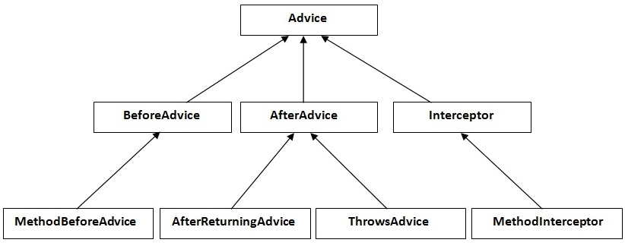

All are interfaces in aop.

**MethodBeforeAdvice** interface extends the **BeforeAdvice** interface.

**AfterReturningAdvice** interface extends the **AfterAdvice** interface.

**ThrowsAdvice** interface extends the **AfterAdvice** interface.

**MethodInterceptor** interface extends the **Interceptor** interface. It is used in around advice.